Nicholas Sammut

Dr. Mark Allison

CIS 525

**Lab Activity 2**

Screenshots of Emulator

1. First Open

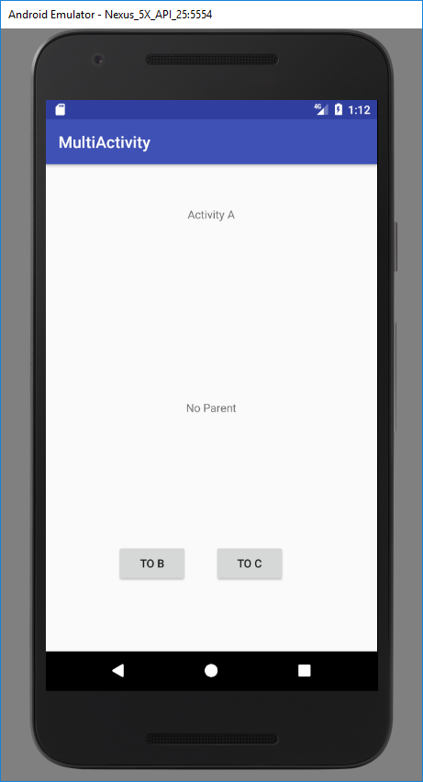

1. Clicked “To C”

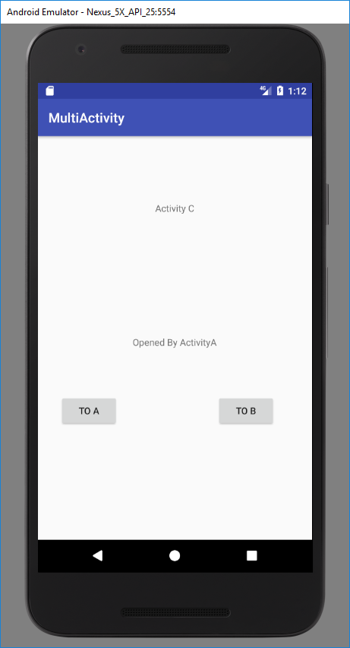

1. Clicked “To B”

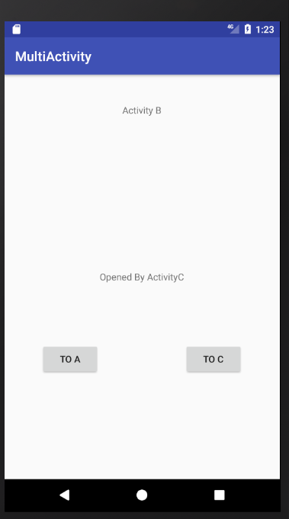

Main .java File (ActivityA [Launcher])

